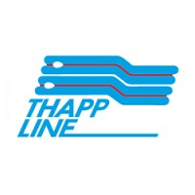


SAP ERP S/4HANA Public Cloud Implementation
For Thai Petroleum Pipeline Co., Ltd
Functional Specification
ZPURF002-PO Form
Document Version: V1.0
Date: 17.08.2026

Approval Signature: Material Management Functional Specification

Thai Petroleum Pipeline Co., Ltd

Approved by: Khun Woranan Tanthiptham  Position: Procurement & Contract Manager  Business Process Owner: MM-PU  Approved Date: |  |  | Approved by: Khun Sirichai Chonbordeechalermroong  Position: Corporate Support Dept. Manager  Business Process Owner: MM-PU  Approved Date:
Approved by: Khun Tagon Thewarangsee
Position: Information System Manager
Business Process Owner: Project Manager
Approved Date:

Document Change Control
This section provides control for the development and distribution of revisions to the Project Charter up to the point of approval. The Project Charter does not change throughout the project life cycle, but rather is developed at the beginning of the project (immediately following project initiation approval, and in the earliest stages of project planning). The Project Charter provides an ongoing reference for all project stakeholders. The table below includes the revision number (defined within your Documentation Plan Outline), the date of update/issue, the author responsible for the changes, and a brief description of the context and/or scope of the changes in that revision.

Revision Number | Date of Issue | Author(s) | Brief Description of Change
V1.0 | 17.08.2026 | Phutachon Aumarit | Initial Document

Table of Contents
1. Development Summary 5
2. Functional Requirements 6
2.1 Authorization 6
2.2 Prerequisites / Assumptions 6
2.3 Detail Program Logic 6
2.4 Conditions 8
2.5 Output Screen 9
3. Testing 10
4. Appendix 10

Development Summary
Object ID | ZPURF001
Object Name | PO Form
Program Name | PO Form
Existing program related (If any)
Module | MMPU
Estimated MDs
Menu Path | Create/Change Purchase Order Advance
FRICEW Type | ☐ Workflow  ☐ Report  ☐ Interface  ☐ Conversion  ☐ Enhancement  ☒ Form | Complexity | ☐ Very High  ☐ High  ☒ Medium  ☐ Low
Statutory | ☐ Yes ☒ No | Frequency | Daily
Processing type | ☒ Online  ☐ Background | Schedule Job | ☒ No  ☐ Yes, (Please define)
Transaction Code | - | Develop By | R2 Development Team
Requested by | Procurement Team | Request Date | 08.07.2026

Functional Requirements

2.1 Authorization

No | Role | Remark
1 | หน่วยงานจัดซื้อ | Role: Procurement

2.2 Prerequisites / Assumptions

No | Description | Remark
1 | เพิ่มรายละเอียด Field ในเอกสาร Purchase Order Form

2.3 Detail Program Logic

No | Program Logic | Remark

ตัวอย่าง PO Form
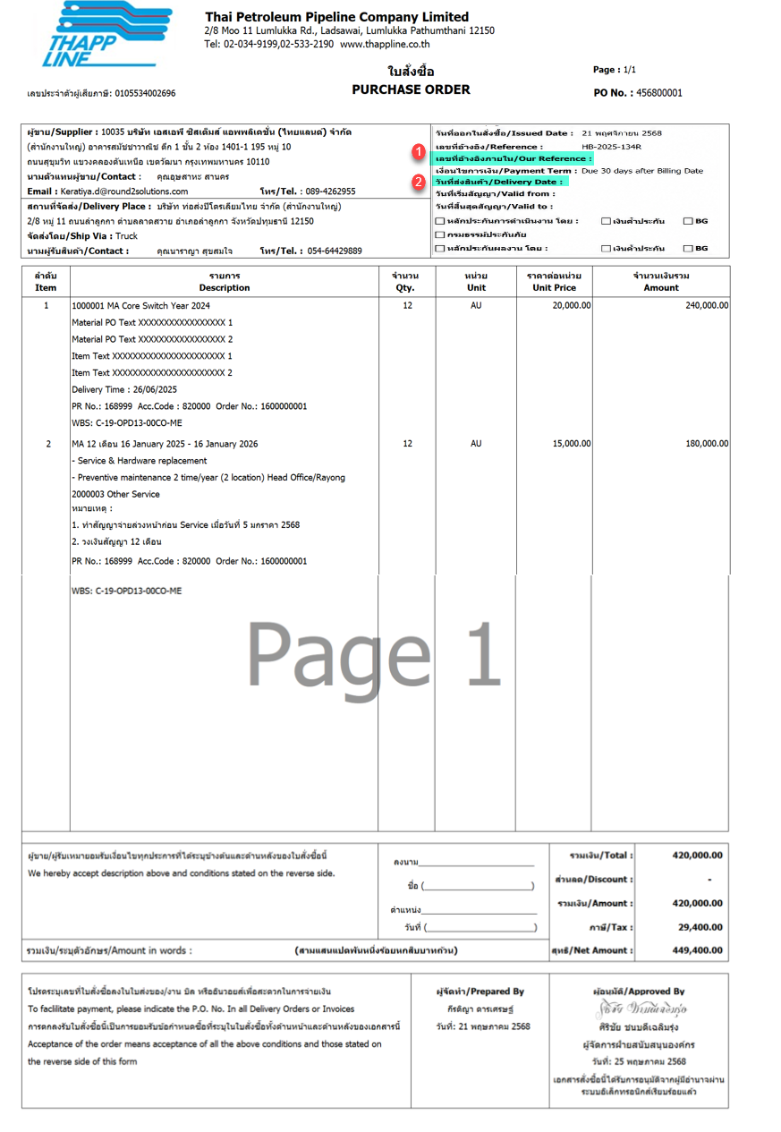

2.4 Conditions

No | Label Text | Application | Field Name | Detail Description
1 | เลขที่เอกสารภายใน/ Our Reference | Purchase Order (Header) | Our Reference | ดึงจาก Purchase order>Tab Communication> Our Reference  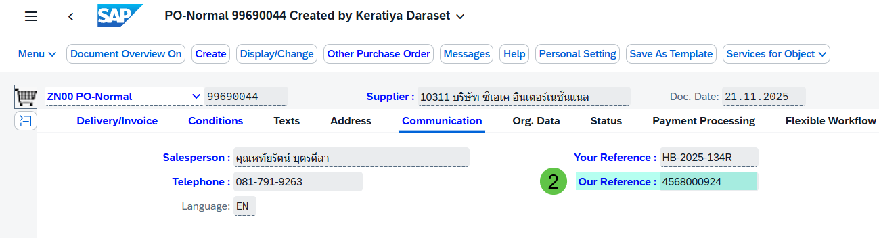
2 | วันที่ส่งสินค้า/Delivery Date | Purchase Order (Line) | Delivery Date | ดึงจากวันที่ Purchase order Item แรกเสมอ  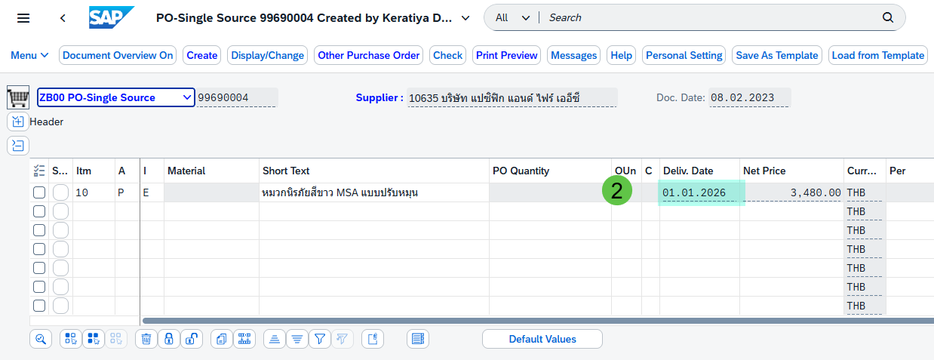

2.5 Output Screen
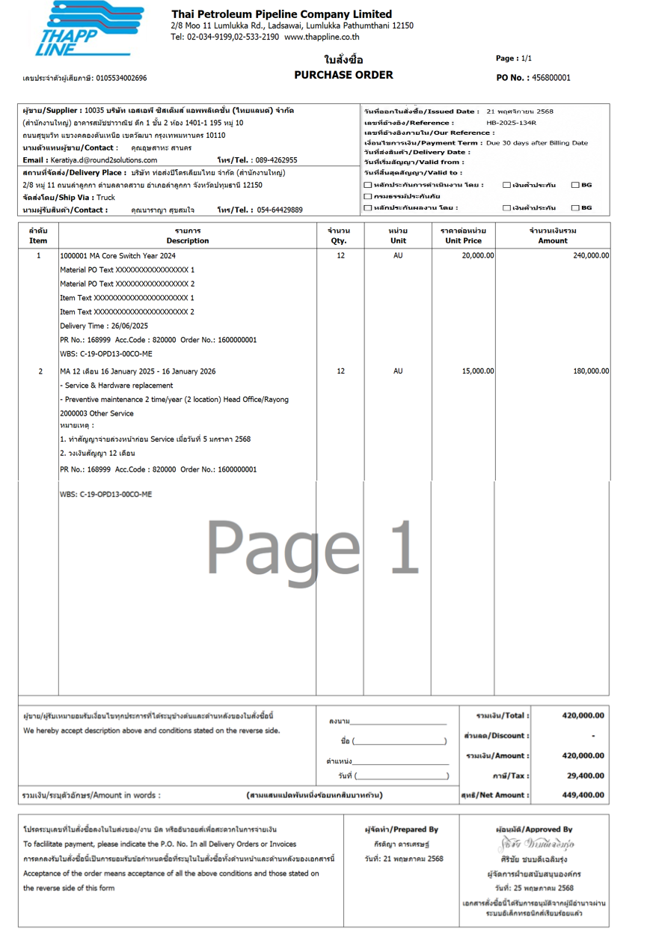

Testing

No. | Description | Expected Result
1. | พิมพ์เอกสาร PO Form | แสดงรายละเอียดของ เลขที่อ้างอิงภายใน/Our Reference และ วันที่ส่งสินค้า /Delivery Date ในรายงานได้ถูกต้องและครบถ้วน

Appendix
N/A

